Distributed Computing Systems
# Source: AI Source: Provided by: [Data Path: Persons Table -> ID Column: 1, Name_En Column: Motasem Essam] -> From: [ChatGPT] on [1/16/2026]
A Distributed Computing System is a type of distributed system where computational tasks are divided among multiple computers (nodes) that work together to solve a single problem or perform a computation.
The goal is to increase computational speed, efficiency, and resource utilization by using parallel or cooperative processing.

Definition
# Source: AI Source: Provided by: [Data Path: Persons Table -> ID Column: 1, Name_En Column: Motasem Essam] -> From: [ChatGPT] on [1/16/2026]
A Distributed Computing System:
- Uses multiple computers connected via a network
- Splits tasks into smaller sub-tasks
- Executes sub-tasks simultaneously or in parallel
- Combines results to produce the final output

Architecture Diagram
# Source: AI Source: Provided by: [Data Path: Persons Table -> ID Column: 1, Name_En Column: Motasem Essam] -> From: [ChatGPT] on [1/16/2026]
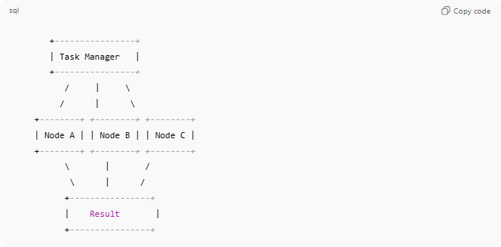
+----------------+
| Task Manager |
+----------------+
/ | \
/ | \
+--------+ +--------+ +--------+
| Node A | | Node B | | Node C |
+--------+ +--------+ +--------+
\ | /
\ | /
+----------------+
| Result |
+----------------+
- Task Manager / Master node: Divides tasks and coordinates nodes
- Worker nodes: Perform computation on assigned sub-tasks
- Result collector: Combines results into final output

Key Characteristics
# Source: AI Source: Provided by: [Data Path: Persons Table -> ID Column: 1, Name_En Column: Motasem Essam] -> From: [ChatGPT] on [1/16/2026]
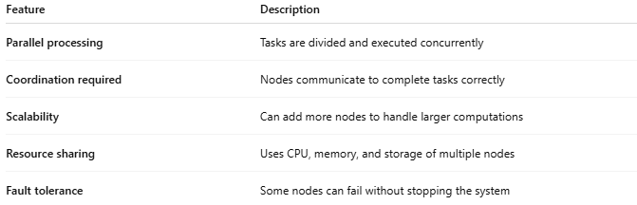
Feature | Description
Parallel processing | Tasks are divided and executed concurrently
Coordination required | Nodes communicate to complete tasks correctly
Scalability | Can add more nodes to handle larger computations
Resource sharing | Uses CPU, memory, and storage of multiple nodes
Fault tolerance | Some nodes can fail without stopping the system

How It Works
# Source: AI Source: Provided by: [Data Path: Persons Table -> ID Column: 1, Name_En Column: Motasem Essam] -> From: [ChatGPT] on [1/16/2026]
- A large computation task is submitted to the task manager
- Task is split into smaller sub-tasks
- Sub-tasks are assigned to different nodes
- Each node processes its sub-task
- Results are combined to generate the final output

Advantages
# Source: AI Source: Provided by: [Data Path: Persons Table -> ID Column: 1, Name_En Column: Motasem Essam] -> From: [ChatGPT] on [1/16/2026]
- Faster computation by parallel execution
- Efficient use of available resources
- Can handle large-scale problems beyond the capacity of a single computer
- Fault tolerance through task replication

Disadvantages
# Source: AI Source: Provided by: [Data Path: Persons Table -> ID Column: 1, Name_En Column: Motasem Essam] -> From: [ChatGPT] on [1/16/2026]
- Complexity in task scheduling and synchronization
- Network overhead can slow down performance
- Failure of nodes requires task reassignment
- Requires careful load balancing

Examples
# Source: AI Source: Provided by: [Data Path: Persons Table -> ID Column: 1, Name_En Column: Motasem Essam] -> From: [ChatGPT] on [1/16/2026]
- SETI@home (analyzing radio signals from space)
- Folding@home (protein folding simulations)
- Apache Hadoop MapReduce (big data processing)
- Weather modeling and climate simulations

Simple Analogy
# Source: AI Source: Provided by: [Data Path: Persons Table -> ID Column: 1, Name_En Column: Motasem Essam] -> From: [ChatGPT] on [1/16/2026]
- Distributed Computing System: A factory assembly line
  - Large product (task) is divided into parts
  - Each worker (node) assembles a part simultaneously
  - Finished parts are combined into the final product

